Task 1

INCLUDE Irvine32.inc

.data

val1 sdword ?

.code

main PROC

mov eax, 0

mov ebx,0

mov eax,8000

;add eax,1

call dumpregs

exit

main ENDP

END main

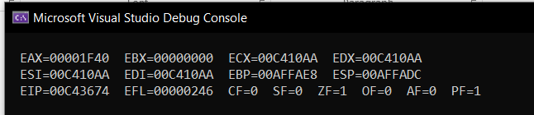

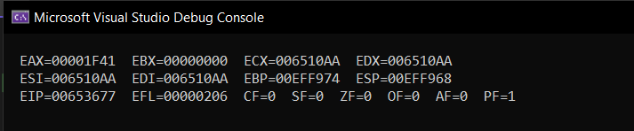

Task 2

Add al,10h ; aCF =1, SF 0=, ZF =1, OF =0

Add al,1 ; CF =0, SF =1, ZF =0, OF =1

Add ax,1 ; CF =0, SF =1, ZF =0, OF =0

INCLUDE Irvine32.inc

.data

arr1 byte 11,24,43,52,61

arr2 byte 5 dup(?)

.code

main PROC

mov eax, 0

mov ebx,0

call dumpregs

mov esi,offset arr1

mov edi, offset arr2

mov ecx, lengthof arr1

l:

movzx eax,byte ptr [esi]

mov byte ptr [edi],al

inc esi

inc edi

call dumpregs

loop l

exit

main ENDP

END main

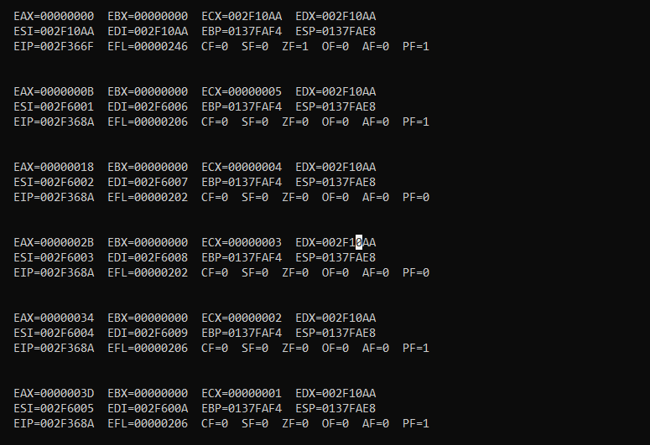

Task 4

INCLUDE Irvine32.inc

.data

arrayB BYTE 10, 20, 30

arrayW WORD 150, 250, 350

arrayD DWORD 600, 1200, 1800

SUM1 DWORD ?

SUM2 DWORD ?

SUM3 DWORD ?

.code

main PROC

movzx eax,arrayB[0]

movzx ebx,arrayW[0]

mov ecx,arrayD[0]

add eax,ebx

add eax,ecx

mov SUM1,eax

call writedec

call crlf

mov eax,0

mov ebx,0

mov ecx,0

movzx eax,arrayB[1]

movzx ebx,arrayW[2]

mov ecx,arrayD[4]

add eax,ebx

add eax,ecx

mov SUM2,eax

call writedec

call crlf

movzx eax,arrayB[2]

movzx ebx,arrayW[4]

mov ecx,arrayD[8]

add eax,ebx

add eax,ecx

mov SUM3,eax

call writedec

call crlf

exit

main ENDP

END main

